## Receiver operator characteristic curve(ROC)

Consider this data which is now one dimensional, so all the red and blue points lie in one line and we want to find the correct split.

* So, we can have a split around here or maybe here or here, all of them are good splits. This is a **good split**.
* Now we can look at this data, which as you can see is perfectly separable over here. This is a **perfect split**.
* Finally, we have this data over here which is pretty much random and there's not much to split here. It seemed that anywhere we put the boundary, we'll have about half blue, half red points on each side. This is a **bad split** or a **random split**.

Now what we want is to come up with a metric or some number that is high for the perfect split, medium for the good split, and low for the random split. In fact, something that gives the perfect split a score of 1.0, the good split something around 0.8, and the random split something around 0.5.

By finding different thresholds for our classification metrics, we can measure the area under the curve (where the curve is known as a ROC curve). Similar to other metrics, when the AUC is higher (closer to 1), this suggests that our model performance is better than when our metric is close to 0.

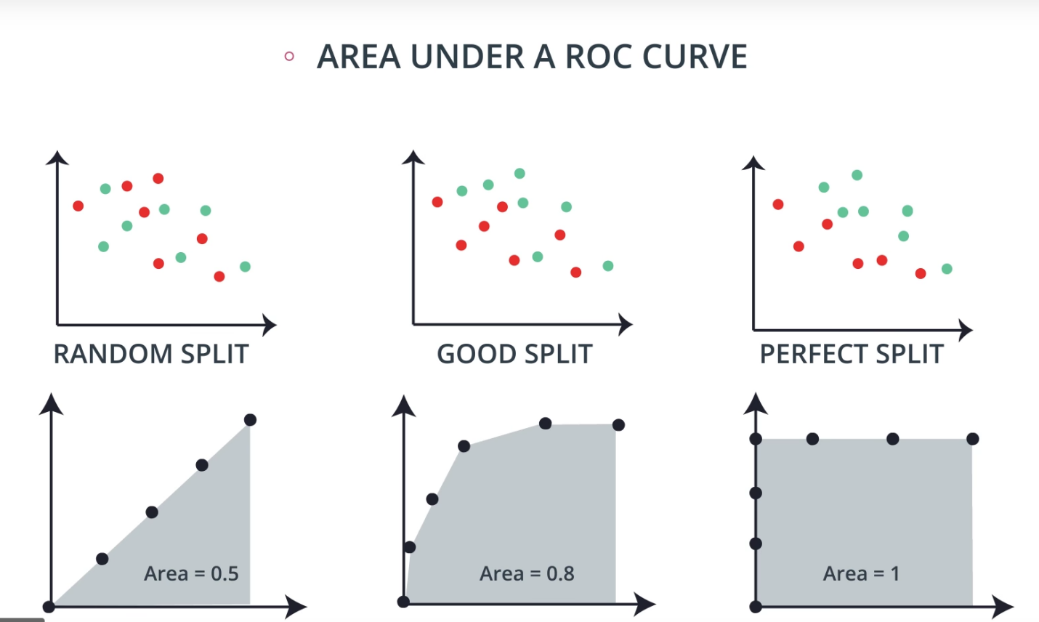

Let's see how to construct these numbers. Let's take our good data and cut it. We'll calculate two ratios:

* The first one is a true positive rate, which means out of all the positively labeled points, how many did we classify correctly? That means the number of true positives divided by the total number of positively labeled points. So let's see how much this is. There are 7 positively labeled numbers and 6 of them have been correctly labeled positive, so this ratio is 6/7 or 0.857.
* Now let's look at the false positive rate, which means out of all the negative points, how many of them did the model incorrectly think they were positives? So out of the 7 negatively labeled points, the model thought 2 of them were positive. So the false positive rate is 2/7 or** **0.286.

We'll just remember these two numbers. Now what we'll do is we'll move the boundary around and calculate the same pair of numbers.

* What is the true positive rate over here? Well, the model thinks everything is positive. So in particular, all the positives are true positives. So the true positive rate is 7/7, which is 1 .
* For the false positive rate, well, since the model thinks everything is positive, then all the negatives are false positives. So the false positive rate is again 7/7, which is 1 .

So again, we'll remember these two values, one and one.

Let's go to the other extreme. Let's put the bar over here

* Let's see what the true positive rate is. Well, the model thinks nothing is positive so in particular, there are no true positives and the ratio is 0/7, which is 0.
* For the false positive rate, well, again, the model thinks nothing is positive, so there are no false positives and the ratio is 0/7, which again is 0 .

We'll remember these two numbers.

We can see that no matter how the data looks, the two extremes will always be 1, 1 and 0, 0. Now, we can do this for every possible split and record those numbers. So here we have a few of them that we've calculated.

*Now, the magic happens.*

* We plot these numbers in the plane and we get a curve. We calculate the area under the curve and here we get around 0.8.
* Next, let's do the same thing for the perfect split. Here are all the ratios. Notice that if the boundary is on the red side, then the true positive ratio is one since every positive number has been predicted positive. Similarly, if the boundary is on the blue side, then every negative number has been predicted negative and so the false positive ratio is 0. In particular, at the perfect split point, we have a 0, 1. Thus, when we plot these numbers, the curve looks like a square and the square has area, one, which means the area under the ROC curve for the perfect split is 1.
* Finally, we do this for the random split. Here you can try it on your own, but basically since every split leaves on each side around half blue, half red points, then each pair of numbers will be close to each other, and the curve will be very close to being just a diagonal between zero, zero and one, one. So if the model is random, then the area under the ROC curve is around 0.5.

## Summary

We have three possible scenarios; some random data which is hard to split, some pretty good data which we can split well making some errors, and some perfectly divided data which we can split with no errors. Each one is associated with a curve. The areas under the curve are close to 0.5 for the random model, somewhere close to one for the good model, so around 0.8, and one for the perfect model.

The closer your area under the ROC curve is to one, the better your model is. Can the area under the curve be less than 0.5? In fact, yes. It can be all the way to zero. How would a model look if the area under the curve is zero? Well, it will look more backwards. It'll have more blue points in the red area and the red points in the blue area, so maybe flipping the data may help.

### **Quiz Question**

True or False: The closer your area under the ROC curve is to zero , the better your model is.

1. True
2. False

### **Quiz Question**

Which of the following statements are true about the area under the curve? (There may be more than one correct answer)

1. around 0.5 for the random model
2. 1.0 for the perfect model.
3. Zero for the perfect model.
4. around 0.8, and one for the good model.